User manual:

Login page: URL / web address – **13.126.202.170**

For admin: User name – [admin@gmail.com](mailto:admin@gmail.com)

Password – admin

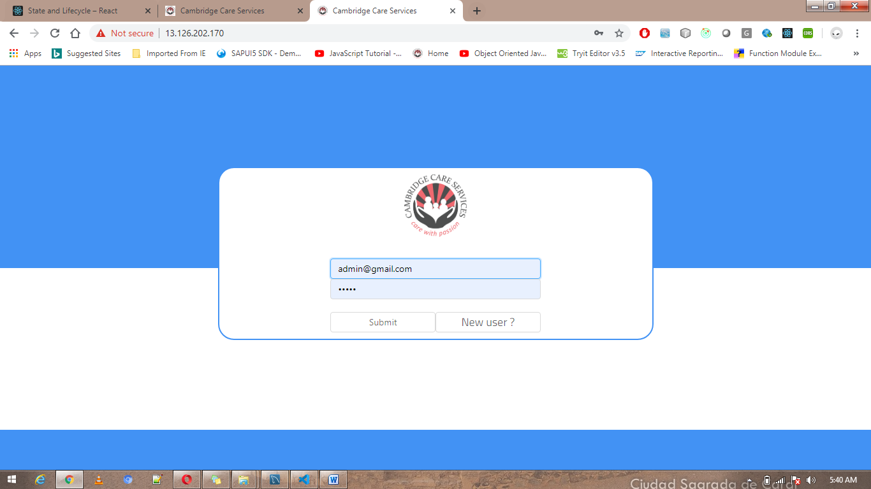

User and admin both can login using same login screen.

Entire application has only one admin account and many user accounts.

**Admin login:**

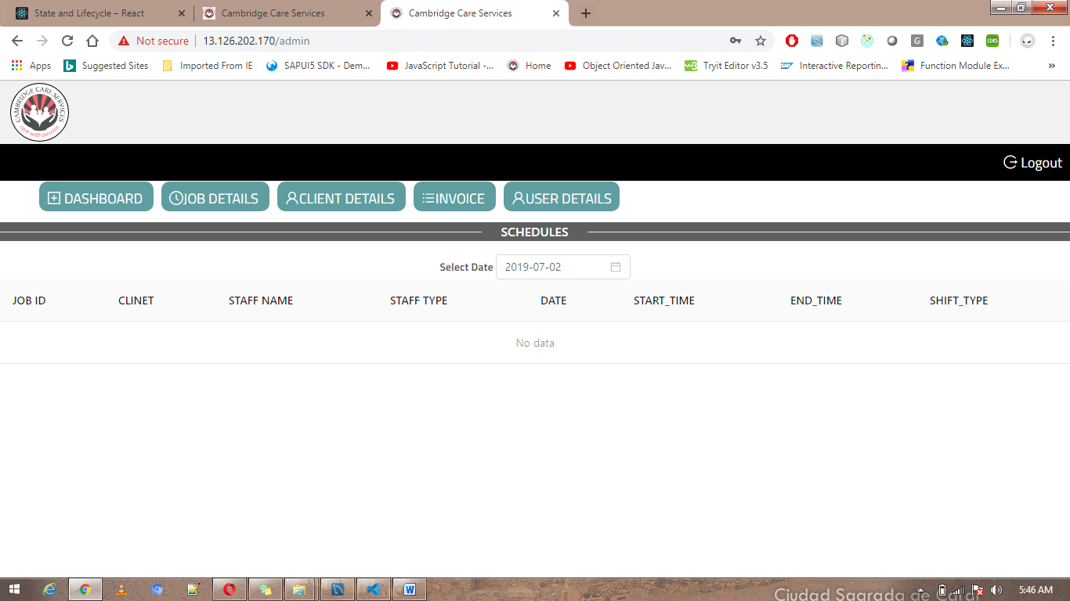

Admin page mainly having 5 sections,

* Dashboard
* Job Details
* Client Details
* Invoice
* User Details

**Dashboard:**

Dashboard screen mainly shows current day job details as below,

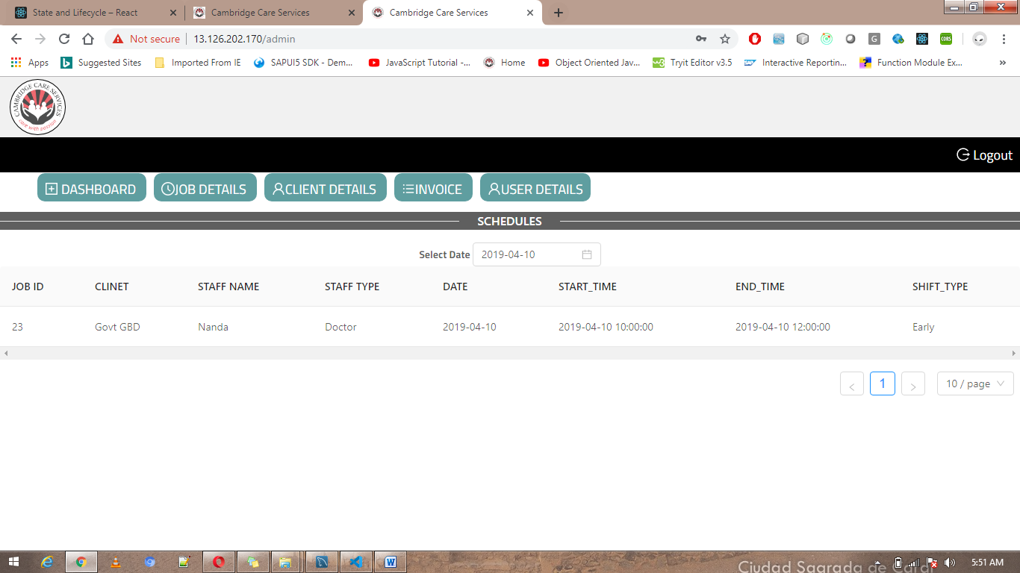

**Job Details:**

Job details screen has 3 sections,

1. Add job
   * 1. We can broadcast new job
2. Scheduled Jobs
   * 1. We can display scheduled jobs in particular date range.
     2. We can delete jobs.
     3. We cannot delete old jobs.
3. Bulk Job Uploads
   * 1. We can upload bulk jobs at a time in below mentioned format.



**Client Details:**

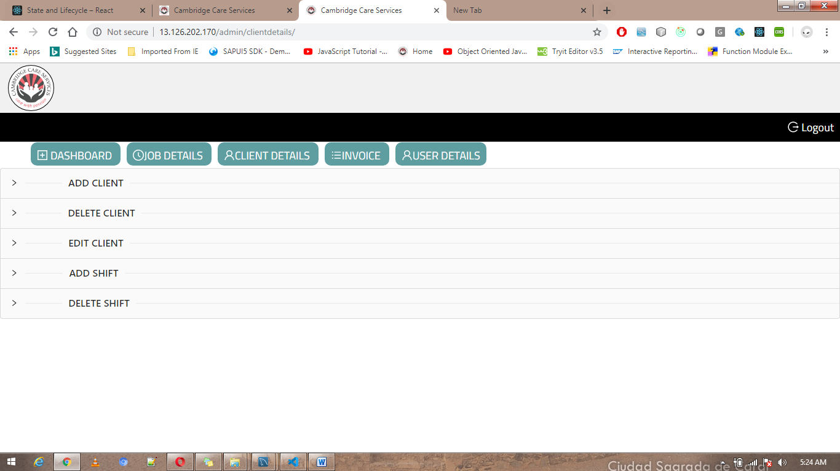

**Client details screen mainly have 5 sections,**

**Add Client :**

**We can add clients (Hospital details)**

**Compulsorily should add client details before scheduling jobs.**

**Please carefully enter client name because we cannot alter client name once client get registered at system.**

**Delete Client :**

**In this section we can enable/disable clients.**

**For disabled clients we cannot schedule jobs.**

**We cannot delete client details permanently because we will be using client details for invoice process and for old jobs references.**

**Edit Client :**

**We can edit client’s details here.**

**We cannot change the client name.**

Add Shifts :

This section mainly used to defining shifts for each client.

Delete Shifts:

We can delete shifts here.

**Invoice:**

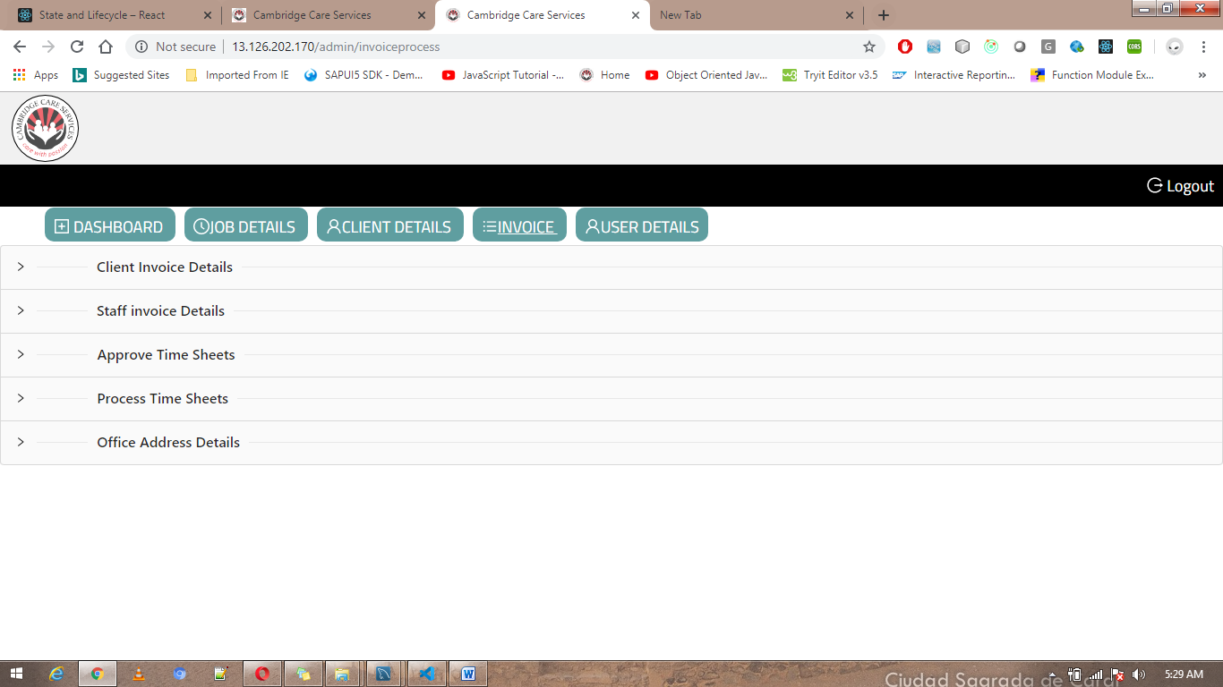

Invoice screen has mainly 5 sections,

* Client invoice details
* Staff invoice details
* Approve Time sheets
* Process Time sheets
* Office Address Details

Client Invoice details :

We can manage client shift charges

Same charges will be used while generating invoice

Staff invoice details :

We can manage staff shift charges

Same charges will be used while generating invoice

Approve Time sheets :

We can see acknowledgement and approve of each staff jobs.

Admin can only approve the completed jobs and can reject any time.

Process Time sheets:

We can generate Invoice for Client for particular date range.

Office address details:

Here we can maintain office address and same will be reflecting in invoice.

User Details:

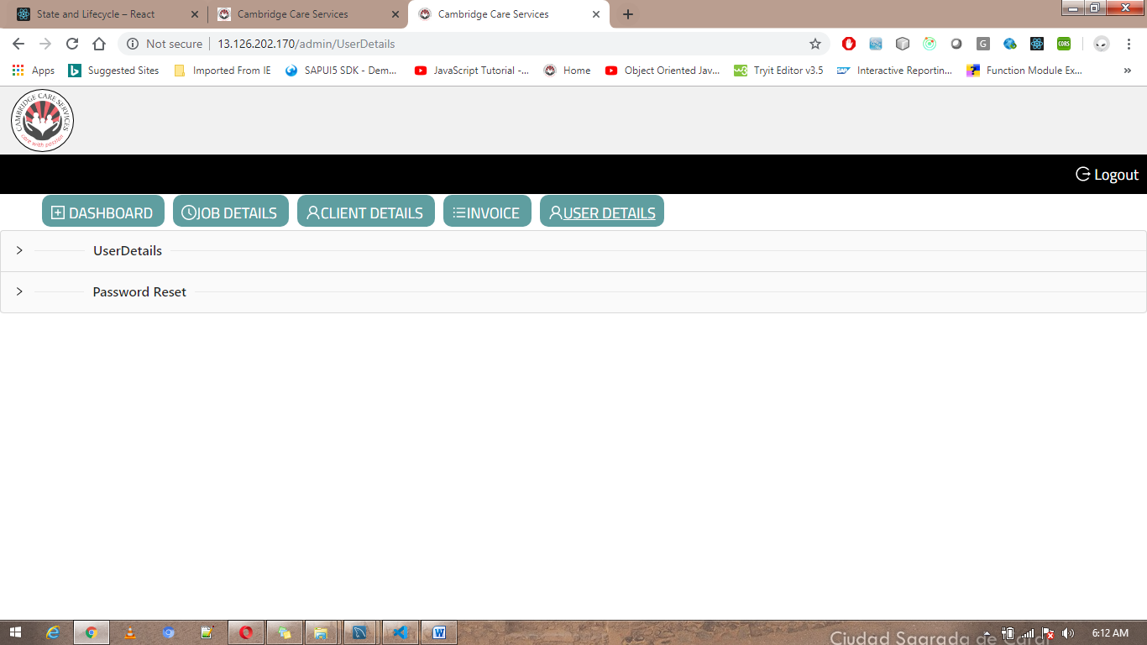

User details screen mainly having 2 sections,

* User Details
* Password Reset

1. User details
   1. We can see all the staff details here
   2. Can enable and disable users here
2. Password reset
   1. We can edit admin login details here.

Staff/User Login:

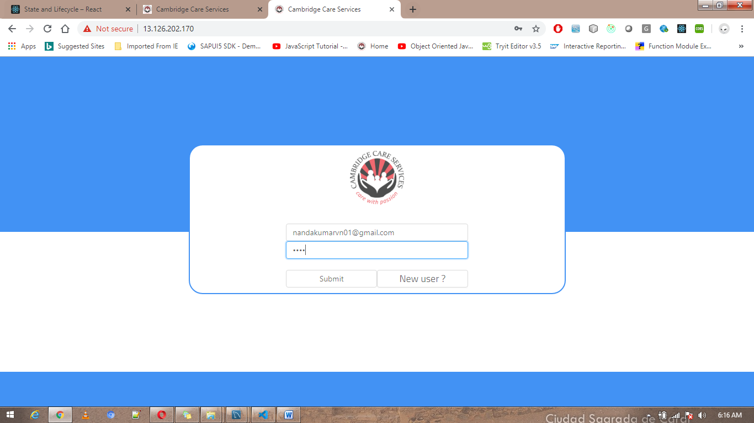

Staff login page mainly have 4 sub screens:

* Dash board
* Job Details
* Submit Time Sheet
* Personal Details

Dashboard:

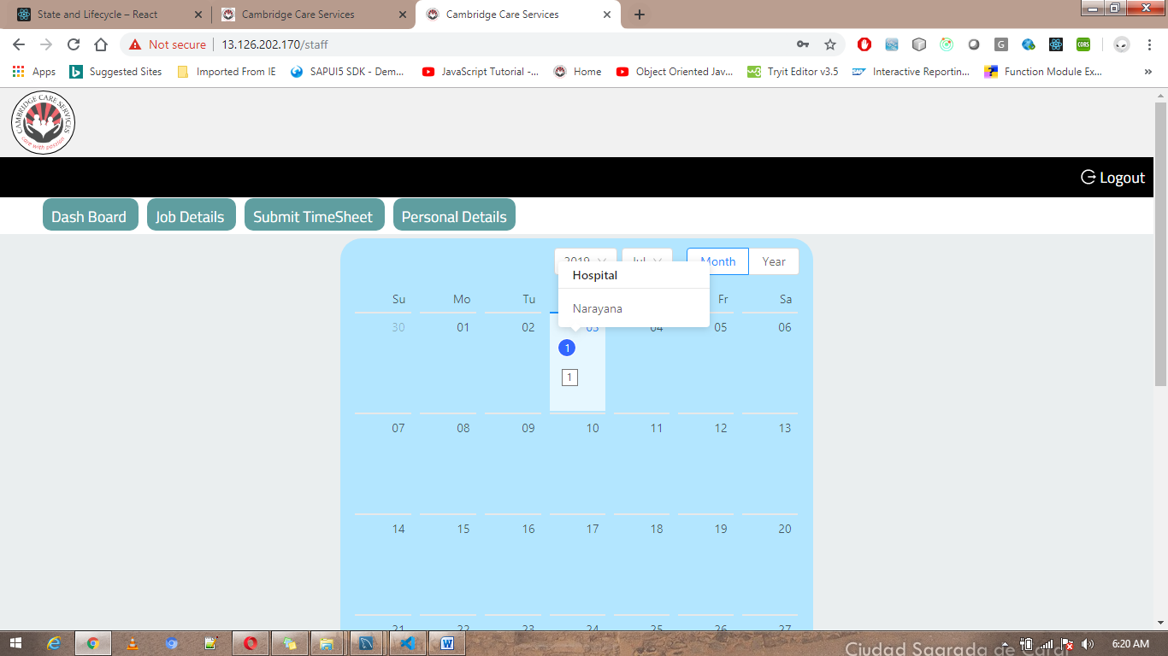

In this screen user can see all the scheduled jobs by admin.

When user click on the date, Respective jobs for the particular date will get display in the below table.

User can accept jobs just by clicking Accept button.

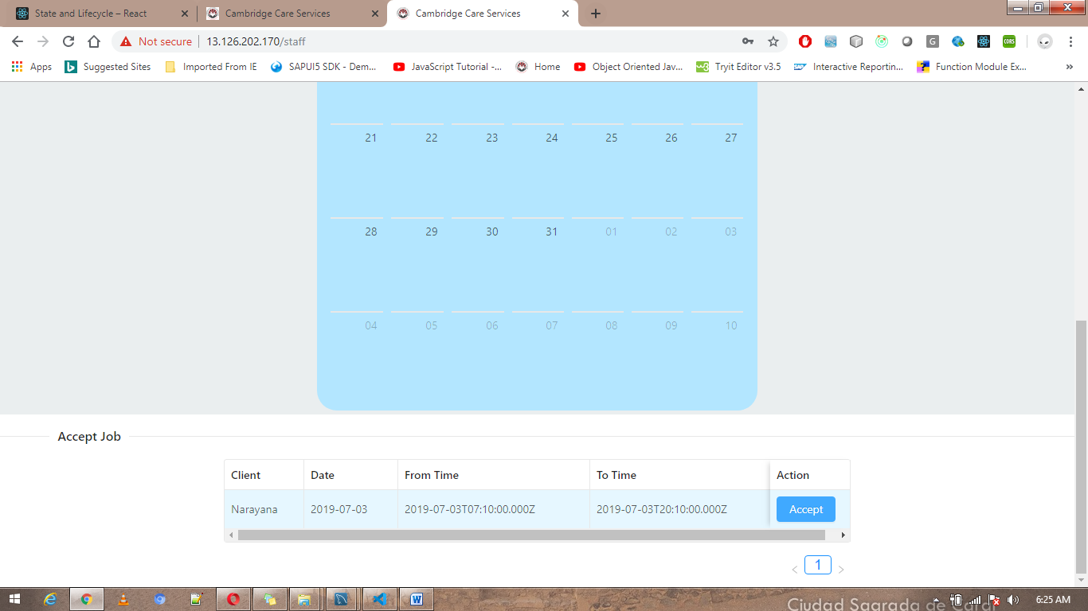

Job Details:

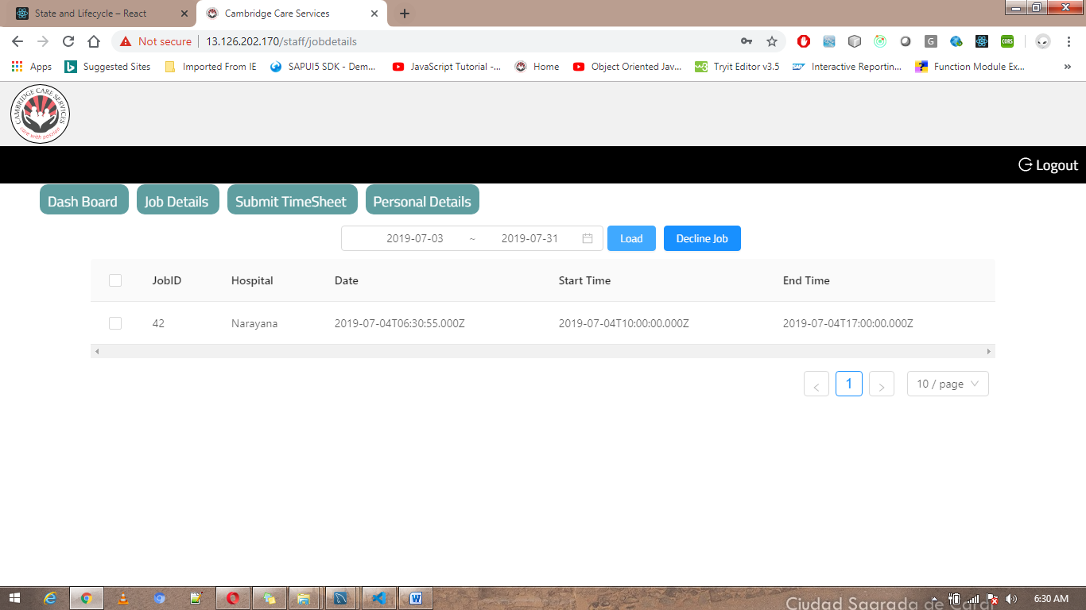

* Job details screen will display all the user accepted job details.
* User can decline job before on scheduled date.

**Submit Time sheet:**

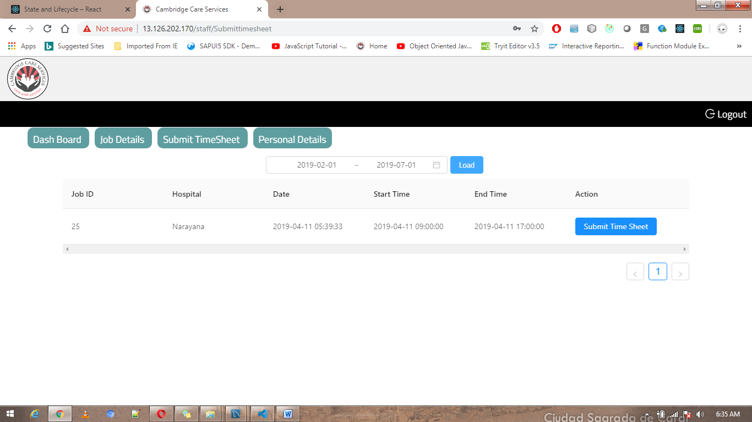

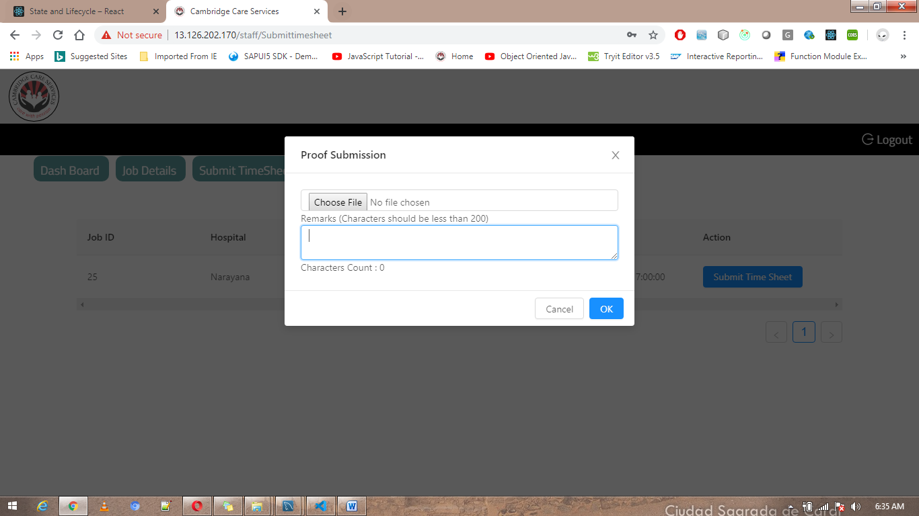

* **In this screen user can submit time sheet with remarks.**
* **User can only submit time sheets for completed jobs.**

**Personal Details:**

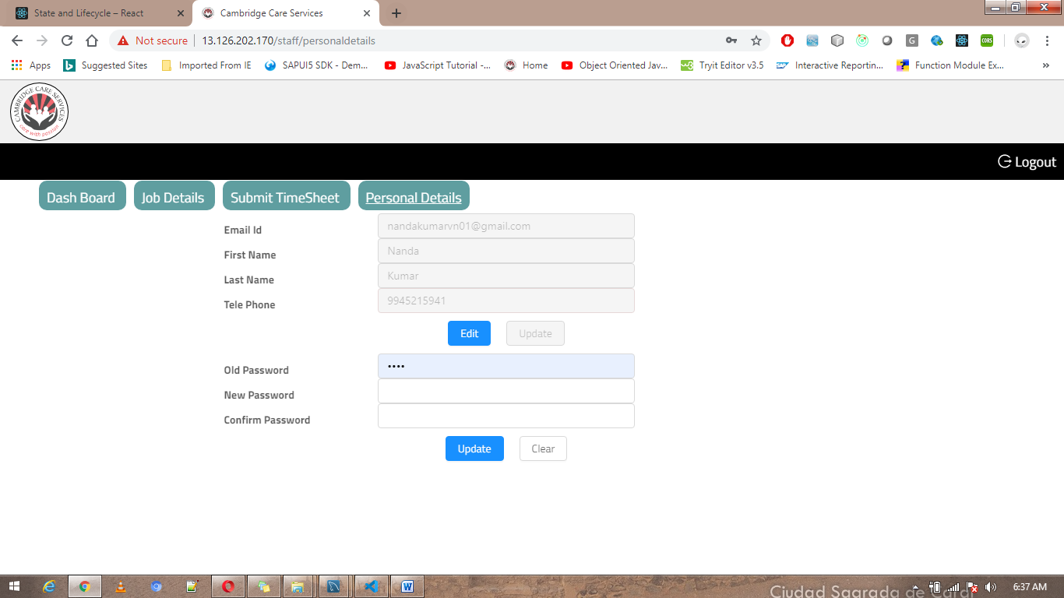

* **In this section user can edit their personal details.**
* **User can reset their password here.**